**BUY THE SELL**

**DESCRIPTION:**

* BTS is an application that creates events, meetings, participants same as how I planner creates, when an information is sent from prism via API BTS, The Information is processed in BTS and sent back to Prism.
* In general, it deals with four kinds of APIs via which the information is sent to prism, the below listed APIs are used from BTS Application to Prism,
* Email
* Private Data
* Product
* Reference Data

**UPLOAD:**

* Here data is sent from Prism to BTS Application.

**PRIVATE DATA:**

* API that includes **POST** comes under private data, there are five main APIs that are included in BTS Application which plays major role in Prism ,each API has it’s own url through which it is involved in prism upon the client.
* List of APIs along with URL and the corresponding prism terms are listed and described below :

**1) POST Upload Internal Contact**:

* In Prism: PrismEmployee
* Request URL: <https://buythesell-east-us.azure-api.net/privatedata/UploadInternalContact>
* Mandatory Keys for Upload Request**:**

|  |  |
| --- | --- |
| NAME | DATATYPES |
| MyContactId | string |
| FirstName | string |
| LastName | string |
| Email | string |
| IsDeactivated | Boolean |

* Description: **UploadInternalContact** is Configured by the following keys and nested keys as attached in the screenshot below ,UploadInternalContact contains json constraints, json,childvalues:
* **JSON Constants and sql:**

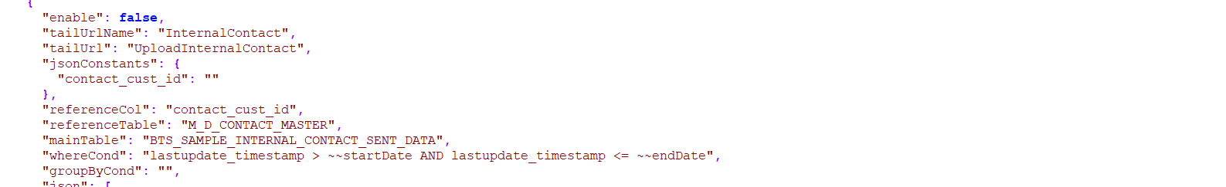

* **JSON :**

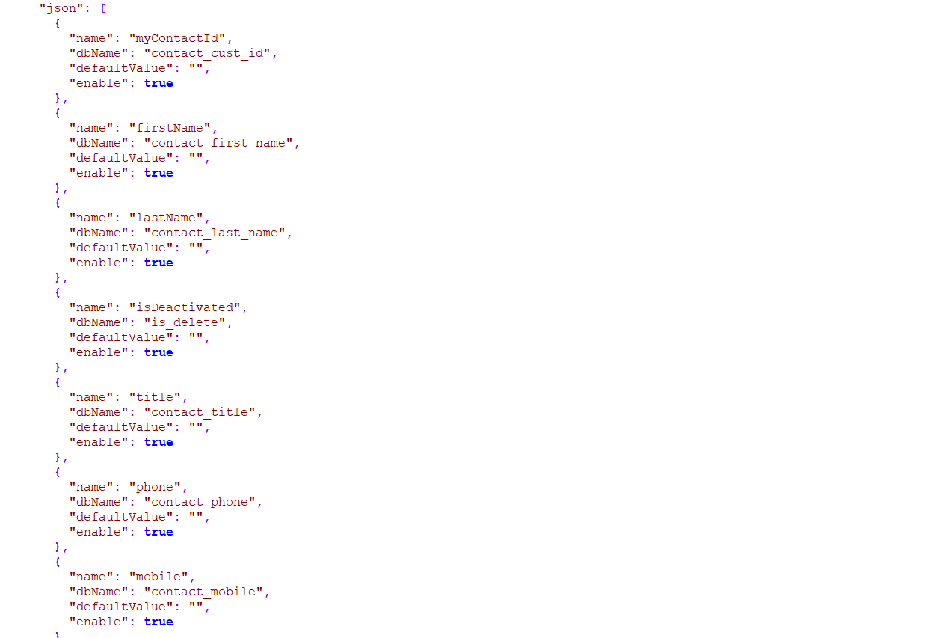

**2)POST UploadFirm:**

* In Prism: PrismAccounts
* Request URL: <https://buythesell-east-us.azure-api.net/privatedata/UploadFirm>
* Mandatory Keys for Upload Request**:**

|  |  |
| --- | --- |
| NAME | DATATYPES |
| MyFirmId | string |
| MyFirmName | string |
| MyParentFirmId | string |
| IsDeactivated | Boolean |

* Descrption: UploadFirm is Configured by the following keys and nested keys as attached in the screenshot,UploadFirm contains json constraints, json,childvalues:
* **json** **constants** **and** **sql**:

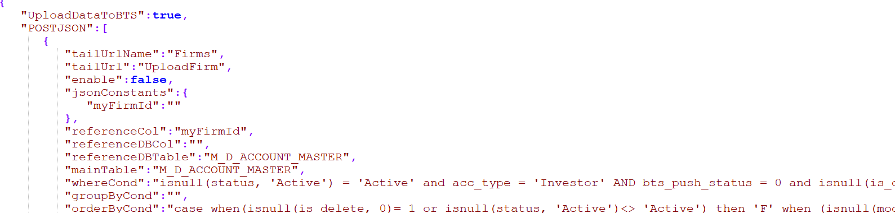

* **json** **and** **childvalues:**

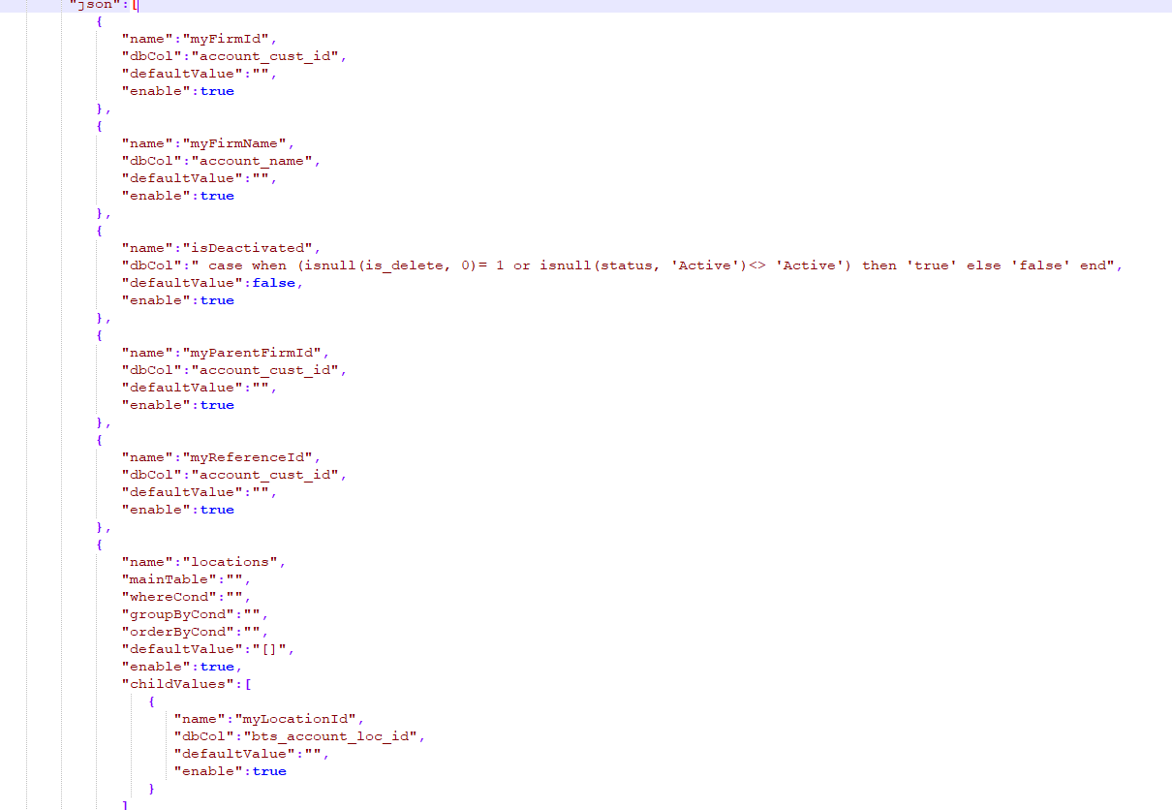

**3)POST UploadContact**:

* In Prism: PrismContact
* Request URL: https://buythesell-east-us.azure-api.net/privatedata/UploadContact
* Mandatory Keys for Upload Request:

|  |  |
| --- | --- |
| NAME | DATATYPES |
| MyContactId | string |
| MyFirmId | string |
| FirstName | string |
| LastName | string |
| IsDeactivated | boolean |

* Description: PrismContact is Configured by the following keys and nested keys as attached in the screenshot, UploadContact contains json constraints, json,childvalues:
* **JSON Constants and childpost:**

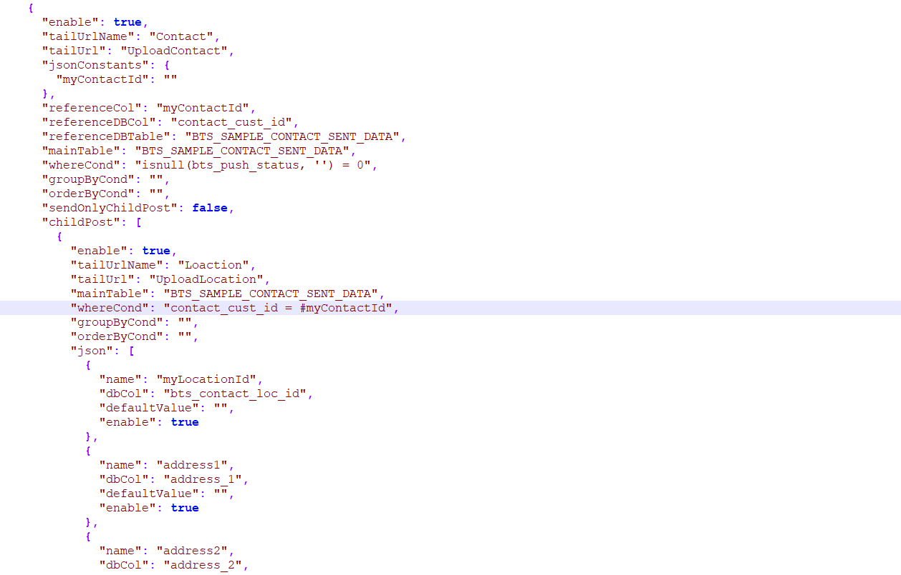

* **JSON and ChildValue:**

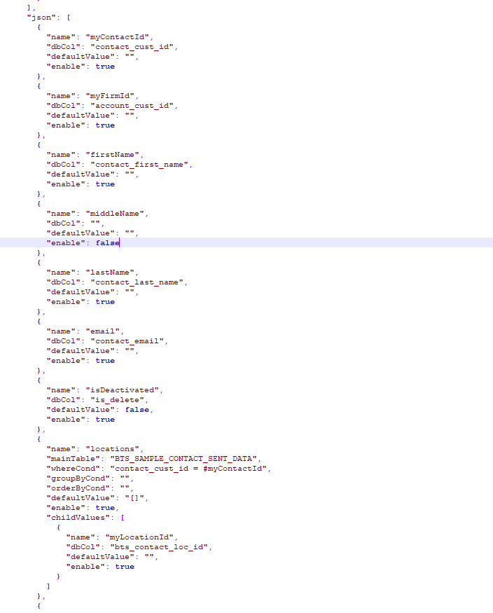

**4)POST UploadSalesCoverageByFirm:**

* In Prism: PrismSalesCoverage
* Request URL: <https://buythesell-east-us.azure-api.net/privatedata/UploadSalesCoverageByFirm>
* Mandatory Keys for Upload Request:

|  |  |
| --- | --- |
| NAME | DATATYPES |
| MyFirmId | string |

* Descrption: PrismSalesCoverage ontact is Configured by the following keys and nested keys as attached in the screenshot,UploadSalesCoverageByFirm contains json constraints, json,childvalues:
* **JSON Constants, JSON,ChildValues:**

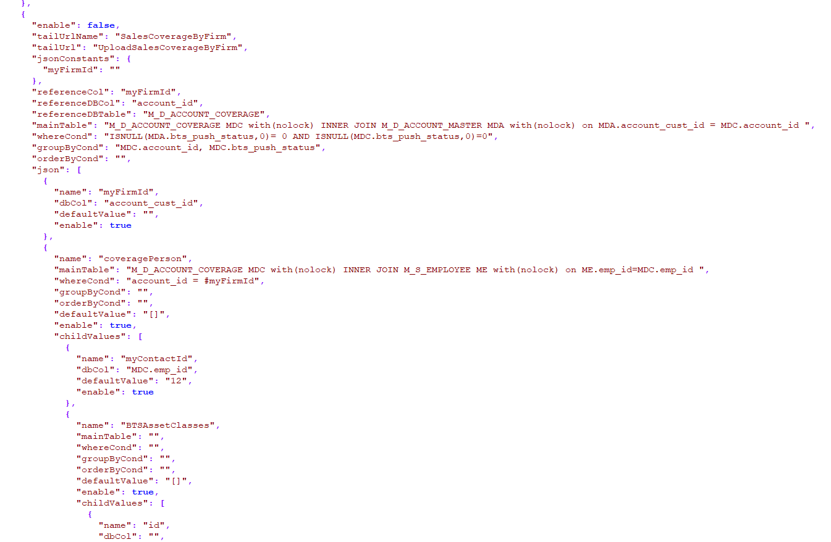

**5)POST UploadAnalystCoverage:**

* In Prism: PrismAnalystCoverage
* Request URL: <https://buythesell-east-us.azure-api.net/privatedata/UploadAnalystCoverage>
* Mandatory Keys for Upload Request:

|  |  |
| --- | --- |
| NAME | DATATYPES |
| MyContactId | string |

* **KEYS AND IT’S DESCRIPTION:**
* **Enable**-Gives information about whether the api is active or inactive
* **TailUrlName**-The request URL name
* **JsonConstants**-Defines the mandatory constants required for the request
* **ReferenceCol**-Json constraints referred as columns
* **ReferenceDBCol**-The respective db columns for constraints in database
* **ReferenceDBTable**-Table that stores each constraints data gets stored
* **MainTable**-Table that stores entire data about the respective API
* **WhereCond**-Query that filters rows that is needed to be uploaded in BTS Application
* **GroupByCond**-Query that groups rows and used with aggregate function
* **OrderByCond**-Query to sort the result set
* **Json**-Json is an array of objects that contains the columns and arrays which are constants
* **Name**-Describes the name of a column or array as a constant of API
* **DbCol**-The respective Db Column of the constant in the local database
* **DefaultValue**-The keys default value irrespective of any condition
* **ChildValues**-Child value can be an object or array of objects that contains columns or arrays
* **ChildPost**-Child post is to be a Subsidiary API of Main API which has keys like main API
* **POINTS TO REMEMBER WHEN MODIFYING PRIVATE DATA:**
* There are objects and Array of objects availabe in the json
* Objects are a 4 key set as referenced below, which shows how the object is taken in the development portal as single constant

|  |  |
| --- | --- |
| This the how each object in Json is carried out in development portal | This the how each constant in development portal is sent as request from Json |
|  |  |

* Arrays are a 7 key set that consists of one or more objects in it and an Array can act as child posts which will have Json as arrays of objects, or it will have childvalues as array of objects.
* If the 7 key array has ChildValues as Array of objects inside them then it looks like as referenced below(Screenshoot), here the objects refer to the 4 key set:

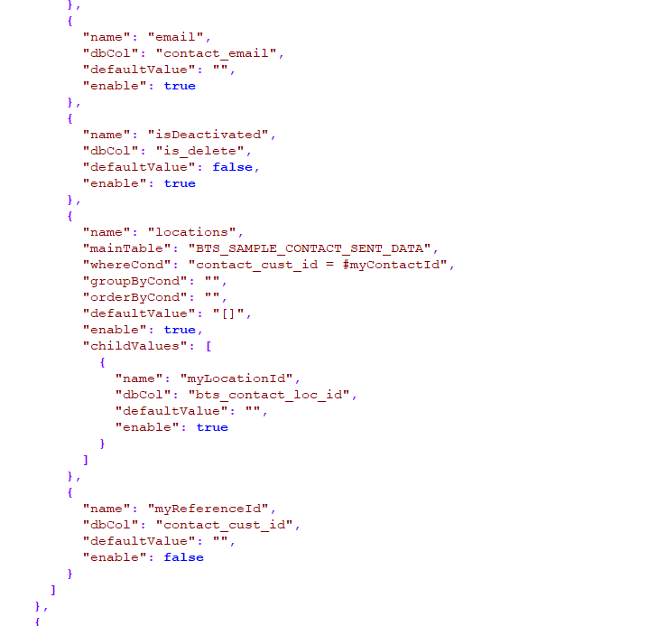

* If the 7 key set acts itself as a childpost which will have Json or child values as objects inside them then it will look like as mentioned below

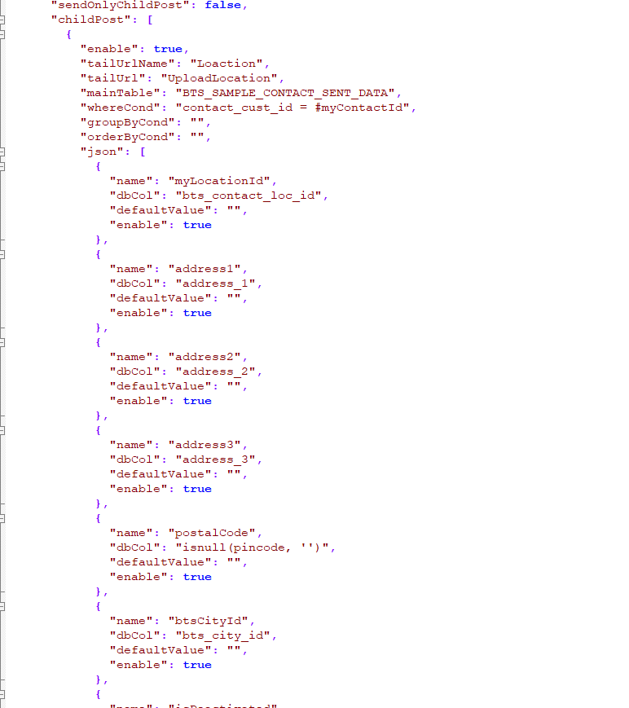

* When adding an object or array the dbCol (key) mentioned should be added in query and Json as well, else the default value will be set out.
* If any object is not necessary in your case, then you can set enable to false so that that specific object will not be taken into consideration.
* When any objects are removed by setting enable to false then the respective column should also be manually removed from the query

**DOWNLOAD:**

* Here the latest data is downloaded from BTS Application to Prism

**PRODUCT:**

* API that includes GET comes under product ,here each API is used to download the latest data from the application,There are six main APIs that is included in BTS Application that plays major role in Prism ,each API has it’s own URL through which the data gets downloaded into prism.
* List of APIs along with URL and the corresponding prism terms and the parameters are listed and described below :

**NOTE**: Instead of modified since and modified until , No of days are being used to download data

**1)GetProductGroups:**

* In Prism: Events- Includes all event related data
* Request URL: [https://buythesell-east-us.azure-api.net/product/GetProductGroups[?modifiedSince][&modifiedUntil][&page][&size][&includingRowCount][&formatTypeIds]](https://buythesell-east-us.azure-api.net/product/GetProductGroups%5b?modifiedSince%5d%5b&modifiedUntil%5d%5b&page%5d%5b&size%5d%5b&includingRowCount%5d%5b&formatTypeIds%5d)
* Parameters:

|  |  |  |  |
| --- | --- | --- | --- |
| NAME | REQUIRED | TYPE | DESCRIPTION |
| modifiedSince | false | string | UTC Time as 24-hour clock format yyyy-MM-ddTHH:mm:ss.fffZ |
| modifiedUntil | false | string | UTC Time as 24-hour clock format yyyy-MM-ddTHH:mm:ss.fffZ |
| page | false | integer | Page No. Default is 1. |
| size | false | integer | Number of records per page. Value must be between 1 and 1000. Default is 100 |
| includingRowCount | false | boolean | True will include row count. False (default value) will return null. |
| formatTypeIds | false | string | Format type id list, e.g. 1,2,3 |

**2)GetProducts:**

* In Prism: Id - provided for grouping of presenter participation in the event for each account.
* Request URL: [https://buythesell-east-us.azure-api.net/product/GetProducts[?modifiedSince][&modifiedUntil][&page][&size][&includingRowCount][&excludeRefDataForDeletedContacts](https://buythesell-east-us.azure-api.net/product/GetProducts%5b?modifiedSince%5d%5b&modifiedUntil%5d%5b&page%5d%5b&size%5d%5b&includingRowCount%5d%5b&excludeRefDataForDeletedContacts)]
* Parameters:

|  |  |  |  |
| --- | --- | --- | --- |
| NAME | REQUIRED | TYPE | DESCRIPTION |
| modifiedSince | false | string | UTC Time as 24-hour clock format yyyy-MM-ddTHH:mm:ss.fffZ |
| modifiedUntil | false | string | UTC Time as 24-hour clock format yyyy-MM-ddTHH:mm:ss.fffZ |
| page | false | integer | Page No. Default is 1. |
| size | false | integer | Number of records per page. Value must be between 1 and 1000. Default is 100 |
| includingRowCount | false | boolean | True will include row count. False (default value) will return null. |
| excludeRefDataForDeletedContacts | false | boolean | True will exclude reference data securities, sector, sectorCoverage and event analystCoverage for deleted contacts. Default is False. |

**3)GetMeetings:**

* In Prism: Meetings- All meeting slot related data
* Request URL: [https://buythesell-east-us.azure-api.net/product/GetMeetings[?modifiedSince][&includingOtherSeller][&includingEmptySlot][&modifiedUntil][&page][&size][&includingRowCount][&includingBuyerAttendee](https://buythesell-east-us.azure-api.net/product/GetMeetings%5b?modifiedSince%5d%5b&includingOtherSeller%5d%5b&includingEmptySlot%5d%5b&modifiedUntil%5d%5b&page%5d%5b&size%5d%5b&includingRowCount%5d%5b&includingBuyerAttendee)]
* Parameters:

|  |  |  |  |
| --- | --- | --- | --- |
| NAME | REQUIRED | TYPE | DESCRIPTION |
| modifiedSince | false | string | UTC Time as 24-hour clock format yyyy-MM-ddTHH:mm:ss.fffZ |
| includingOtherSeller | false | boolean | True will include other Sellers requests that have been shared with your firm, or that you have entered on behalf of another Seller. False (default value) will ensure retrieval of only those requests that your organization has entered or have been attributed to your firm by another organization; ie for a deal roadshow where some meetings maybe arranged by a different Bookrunner choosing false will ensure those meetings are ignored in the download. |
| includingEmptySlot | false | boolean | True will include empty slots ie those slots that do not have a buyer (investor). False (default value) will ensure only interactions that include a buyer will be downloaded. If the requirements are only to populate a CRM or data warehouse with client (Investor) activity we recommend setting this parameter to be false. |
| modifiedUntil | false | string | UTC Time as 24-hour clock format yyyy-MM-ddTHH:mm:ss.fffZ |
| page | false | integer | Page No. Default is 1. |
| size | false | integer | Number of records per page. Value must be between 1 and 1000. Default is 100 |
| includingRowCount | false | boolean | True will include row count. False (default value) will return null. |
| includingBuyerAttendee | false | boolean | True (default value) will include buyer attendees data. False will return null. |

**4)GetFirms:**

* In Prism: Accounts-All the contacts accounts participation in the meeting slots.
* Request URL: [https://buythesell-east-us.azure-api.net/product/GetFirms/{type}[?modifiedSince][&includingComment][&includingAnswer][&modifiedUntil][&page][&size][&includingRowCount](https://buythesell-east-us.azure-api.net/product/GetFirms/%7btype%7d%5b?modifiedSince%5d%5b&includingComment%5d%5b&includingAnswer%5d%5b&modifiedUntil%5d%5b&page%5d%5b&size%5d%5b&includingRowCount)]
* Parameters:

|  |  |  |  |
| --- | --- | --- | --- |
| NAME | REQUIRED | TYPE | DESCRIPTION |
| type | true | string | All/Presenter/Buyer/Seller/Other |
| modifiedSince | false | string | UTC Time as 24-hour clock format yyyy-MM-ddTHH:mm:ss.fffZ |
| includingComment | false | boolean | True will include all comments. False (default value) will exclude comments data. |
| includingAnswer | false | boolean | True will include all answers. False (default value) will exclude answers data. |
| modifiedUntil | false | string | UTC Time as 24-hour clock format yyyy-MM-ddTHH:mm:ss.fffZ |
| page | false | integer | Page No. Default is 1. |
| size | false | integer | Number of records per page. Value must be between 1 and 1000. Default is 100 |
| includingRowCount | false | boolean | True will include row count. False (default value) will return null. |

**5)GetContacts:**

* In Prism: contacts- All the contacts participation in the meeting slots.
* Request URL: [https://buythesell-east-us.azure-api.net/product/GetContacts/{type}[?modifiedSince][&includingComment][&includingAnswer][&modifiedUntil][&page][&size][&includingRowCount](https://buythesell-east-us.azure-api.net/product/GetContacts/%7btype%7d%5b?modifiedSince%5d%5b&includingComment%5d%5b&includingAnswer%5d%5b&modifiedUntil%5d%5b&page%5d%5b&size%5d%5b&includingRowCount)]
* Parameters:

|  |  |  |  |
| --- | --- | --- | --- |
| NAME | REQUIRED | TYPE | DESCRIPTION |
| type | true | string | All/Presenter/Buyer/Seller/Other |
| modifiedSince | false | string | UTC Time as 24-hour clock format yyyy-MM-ddTHH:mm:ss.fffZ |
| includingComment | false | boolean | True will include all comments. False (default value) will exclude comments data. |
| includingAnswer | false | boolean | True will include all answers. False (default value) will exclude answers data. |
| modifiedUntil | false | string | UTC Time as 24-hour clock format yyyy-MM-ddTHH:mm:ss.fffZ |
| page | false | integer | Page No. Default is 1. |
| size | false | integer | Number of records per page. Value must be between 1 and 1000. Default is 100 |
| includingRowCount | false | boolean | True will include row count. False (default value) will return null. |

**6)GetRequests:**

* In Prism: Requested contacts list for the meeting slots
* Request URL: [https://buythesell-east-us.azure-api.net/product/GetRequests[?modifiedSince][&modifiedUntil][&page][&size][&includingRowCount](https://buythesell-east-us.azure-api.net/product/GetRequests%5b?modifiedSince%5d%5b&modifiedUntil%5d%5b&page%5d%5b&size%5d%5b&includingRowCount)]
* Parameters:

|  |  |  |  |
| --- | --- | --- | --- |
| NAME | REQUIRED | TYPE | DESCRIPTION |
| modifiedSince | false | string | UTC Time as 24-hour clock format yyyy-MM-ddTHH:mm:ss.fffZ |
| modifiedUntil | false | string | UTC Time as 24-hour clock format yyyy-MM-ddTHH:mm:ss.fffZ |
| page | false | integer | Page No. Default is 1. |
| size | false | integer | Number of records per page. Value must be between 1 and 1000. Default is 100 |
| includingRowCount | false | boolean | True will include row count. False (default value) will return null. |

* **POINTS TO REMEMBER WHEN MODIFYING PRODUCT:**
* Here Parameters are the array of objects, and each object is a 3 key set ,

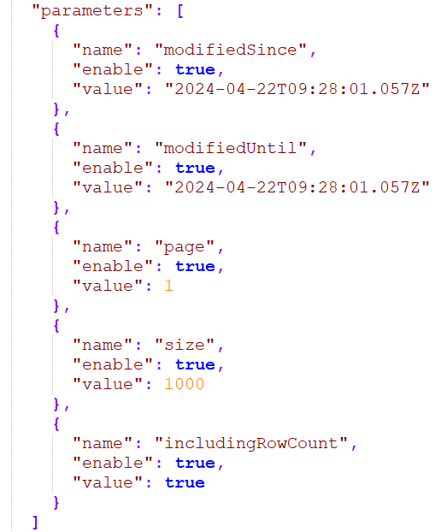

* Whenever any kind of changes made in the product(Download) make sure these values are maintained because these are constant values

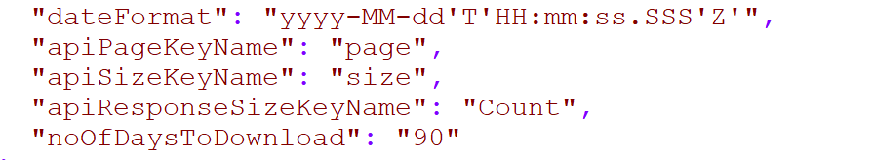

* In case if any of the parameters has to be removed as per the client’s required then the enable key of respective object of parameter can be set to false so that it will not be taken into consideration when request is sent

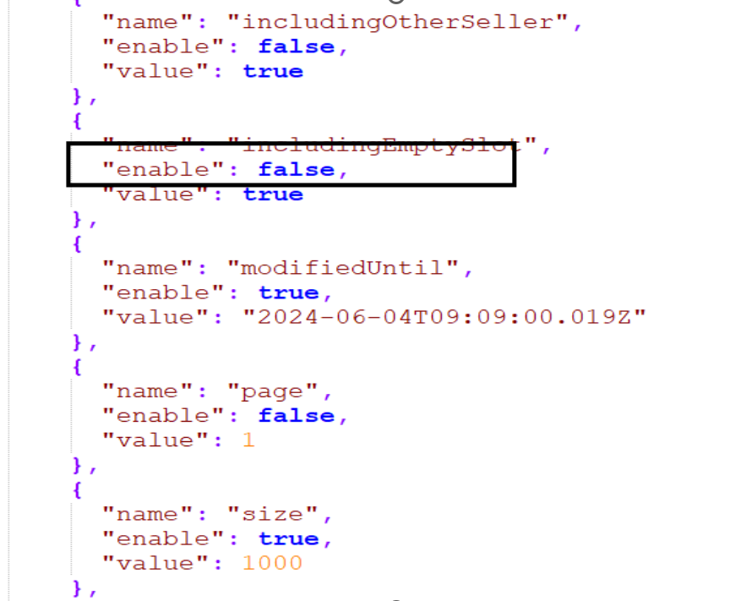

**STEPS TO BE FOLLOWED:**

* **Prerequisites :**
* Login and navigate to the following git url : <http://git.datazoic.com/prism20/Product-BTS-Downloader>
* Download the following scripts from the git URL provided to your local and execute them in the same order:

1. Schemas- <http://git.datazoic.com/prism20/Product-BTS-Downloader/tree/master/Schema>
2. Constants-<http://git.datazoic.com/prism20/Product-BTS-Downloader/tree/master/Constant>
3. Procedure-<http://git.datazoic.com/prism20/Product-BTS-Downloader/tree/master/Procedures>

* Once the scripts are executed successfully the code set up must be done
* **Code Setup:**
* There are two main aspects of BTS that must be setup to modify the Json, and both vary based on the API and the Clients handled

1. Request URL
2. Respective Subscription Key

* Sample for how the API’s Request URL, and the respective Subscription Key should look like are referenced below (Screenshot),
* For Upload: The URL should vary upon the client and API request and to reach out to the URL and the Respective Subscription key and modify them follow the below steps :
* Step 1 – Search the API that has to be sent as request

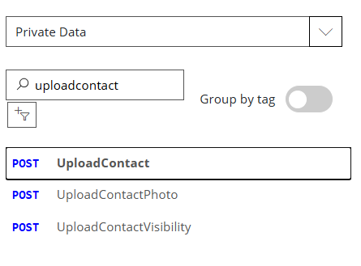

* Step 2 – The Url and Respective Subscription key could be found in different ways, In order to find then, the first way would be in the main page and second way is after clicking try, to find it easier the screenshots are referenced below (Can find them among any options referenced below)

A) 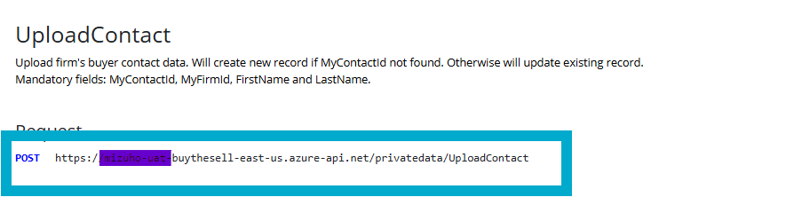

B)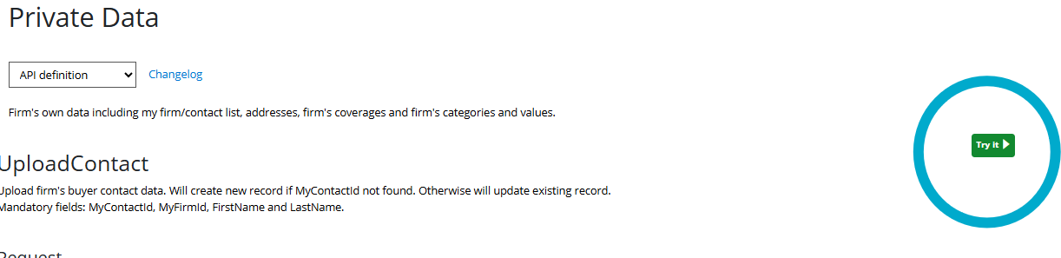

C)

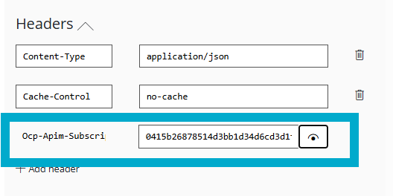

D)

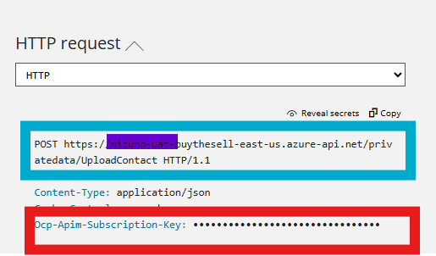

* For Download: The URL should vary upon the client and API request and to reach out to the URL and the Respective Subscription key follow the below steps
* Step 1 – Search the API that has to be sent as request from product

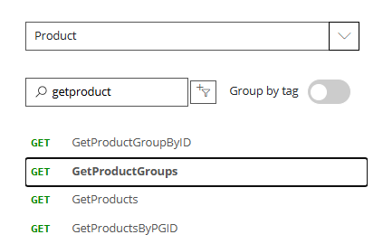

* Step 2 – The Url and Respective Subscription key could be found in different ways, In order to find then, the first way would be in the main page and second way is after clicking try, to find it easier the screenshots are referenced below (Can find them among any options referenced below)

A)

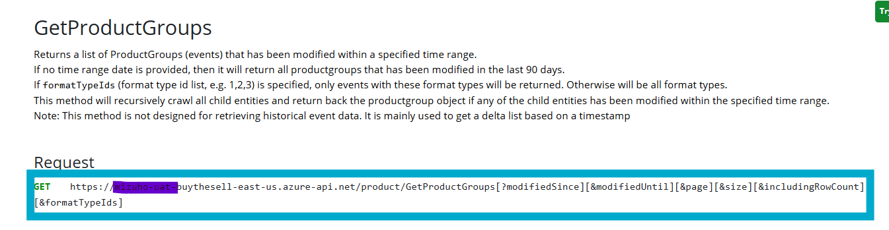

B)

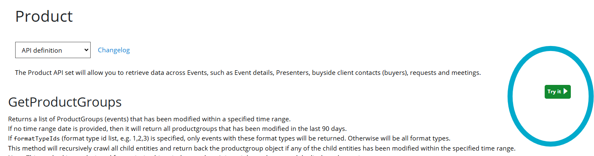

C)

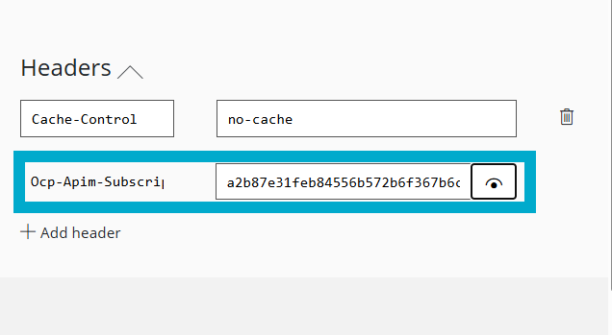

D)

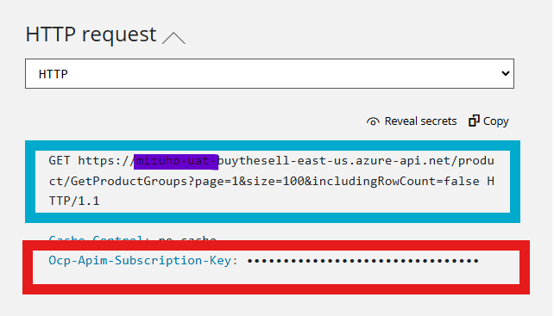

* **Modifications:** There are certain criteria and steps that must be followed when making modifications in the Json
* Modify constant, Schemas and procedure as per the client's requirement be it any kind of APIs that are to be modified
* When comes to modify the Json of specify Api there are two cases :
* **Case 1**- Modifying the Json in Private Data (Upload)
* **Case 2**- Modifying the Json in Product (Download)
* Please refer to the points to remember that is described in ( ) for both the cases
* **Updating of Json:** Once the modifications are made, the following steps must be followed for the modifications to reflect in the application as per the client’s requirement
* The following checks must be made:
* Check the modification ae made on the standards mentioned above
* Check whether the brackets are opened and closed in appropriate way
* Double Check the modifications made because the parent value if modified the subsequent child values will be affected
* Once all the checks are done update the Json in the admin console for the modifications to reflect in BTS Application upon client’s requirement

**REFERENCE DATA:**

* BTS provides public information including countries and cities, here if any new ticker is initiated by client, then that information is to be inserted by us manually into BTS_REF_MASTER_FIRM_TICKER table in prism because this API only works based on ticker symbol that is provided by the client and one ticker symbol can have many responses ,so to choose appropriate response that is needed we do the insertion manually.
* The appropriate response should be choosen based on client's region – bloombergSymbol(Key)
* There are two keys that must be taken from the appropriate response and inserted into the table BTS_REF_MASTER_FIRM_TICKER
* masterFirmId
* FirmName
* STEPS TO FOLLOW WHEN HANDLING WITH REFERENCE DATA:
* Search for the API GetMasterFirmTickerId which gives reponses on Reference data

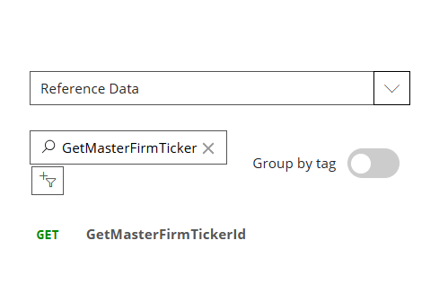

* Modify the Request URL and the Reference Subscription key based on the clients handled

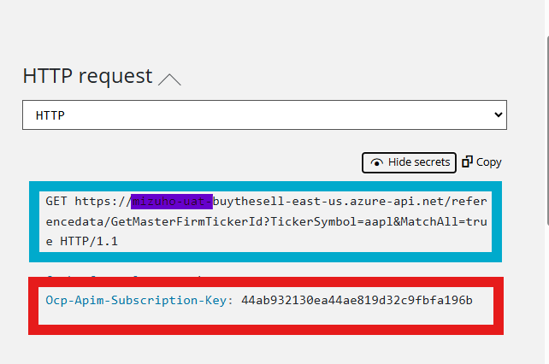

* Send Request Based on the Ticker Symbol that the client provided, for example if the Ticker Symbol is – AAPL provided by the client then send request as referenced below (Screenshots)

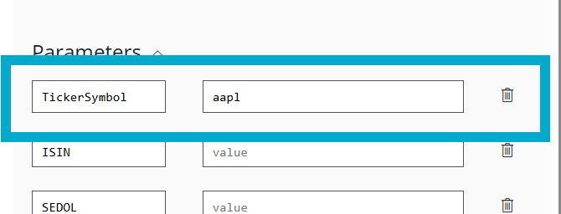

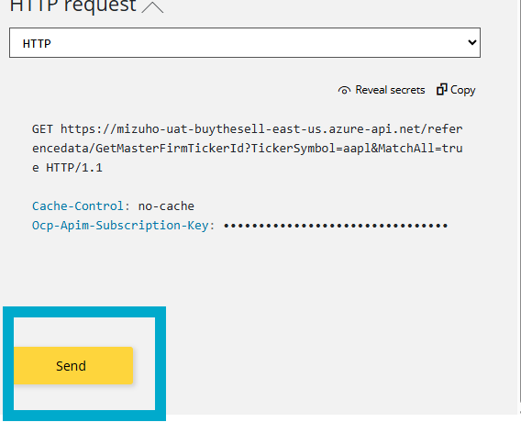

* Once the request is sent along with the ticker symbol provided by the client, then response will be received as referenced below 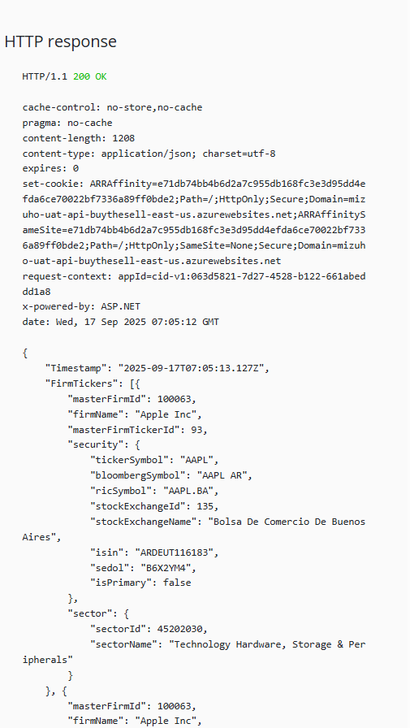
* Choose the appropriate response based on your client’s region , you can find them on the key bloombergSymbol, take for example if you client region is US then choose the entire reponse appropriately

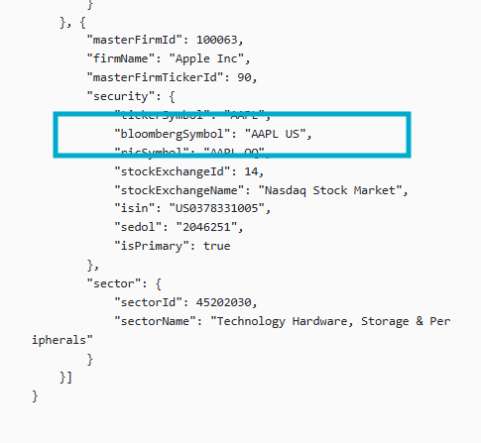

* Once the appropriate response is figured out insert the value of keys masterFirmId and firmName into the table BTS_REF_MASTER_FIRM_TICKER manually .

